# Week 3 – Assignment 2 – Hypothesis Testing

By: Zach Adair

Regis University

MSDS 650: Data Analytics

## Introduction

Hypothesis testing is the practice of testing a hypothesis by comparing it with a null hypothesis. The null hypothesis is known as the status quo, then there is also the alternative hypothesis which is the other side of the null which if the null is rejected that is what the hypothesis will change to. In this assignment I will be testing two different methods that can be made on the same population or where there are before and after results on the same populations, the paired t-test is used. The paired t-test is a test for the equality of means, given two samples with unknown variances. This test can’t be used unless each set of data is related in some way.

## Step 1

In this first step, we will input the two sets of paired samples – we want to determine if there has been enhancement, decline, or if the means have stayed the same under the new coach’s training method. In the first step we are needing to determine if the blood pressure medicine XYZ has a positive, negative or neutral effect on the group testing the medicine.

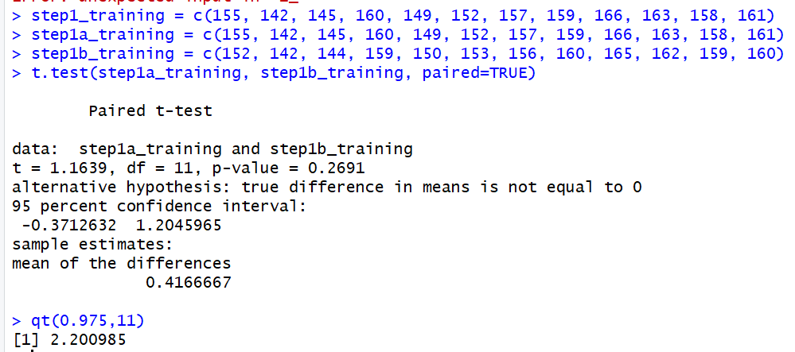

In the first step I created the two vectors for the data needed to test the paired t-test than ran the paired t-test through the RStudio command. After run the result was that t = 1.1639, degrees of freedom = 11, p-value = 0.2691, the sample estimates mean of the differences = 0.41667, and the 95% confidence interval was set at (-0.3712632, 1.2045965). The results from this test would conclude that the null hypothesis would not be rejected and the we could the new drug for blood pressure has a positive effect on the groups blood pressure results.

## Step 2

In step two we will be looking at an addition to our R t-test command; with the addition of the alt=”less” or alt=”greater” we are asking R to test whether the mean of values in the first vector are less than or greater than the mean of the values in the second vector. The goal of step 2 is to take our original blood pressure numbers and give our test subjects drug ABC and see if the results are greater than the mean of the values or less than the mean of values for the results.

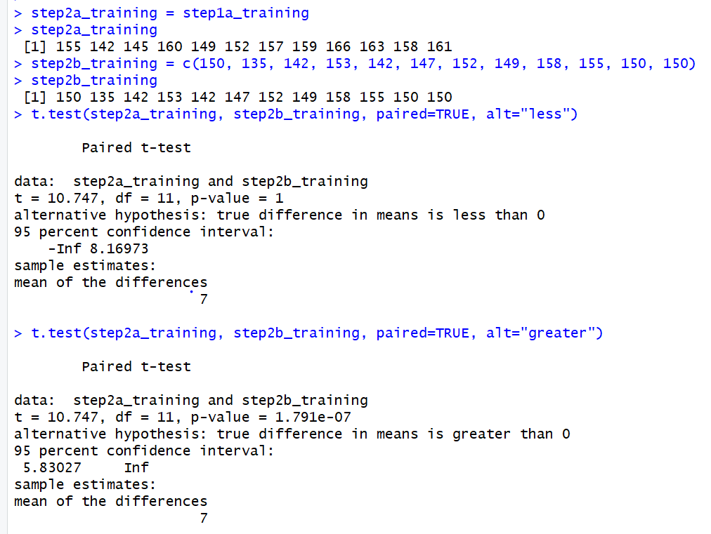

From the results of step 2 we know that the drug ABC are less than the original blood pressure numbers, which means the ABC drug is effective at lowering blood pressure which is good and what we want out of the drug.

## Summary

In this exercise I got to run t-test to test hypothesis testing with blood pressure drug test results. In step 1, we got to test the t-test results to see if the first drug, XYZ effectively changed the blood pressure of the group, which it did based on the results of the test and the p-value which was greater than the alpha of 0.05. The next step we got to test the blood pressure against the results of drug ABC and what was different about how we tested ABC is we were able to check and see if the blood pressure was less than or greater than after the drug was taken. This was great to use because you are able to see in which way the drug effected the blood pressure of the people in the group. Being able to do this outside of this data is great because it allows an analyst to know the change in the data either it be positive, negative or neutral and the data it can show the effectiveness of whatever you are trying to study.